**Link Bot**

Group No. 2

**Team Members**

|  |  |
| --- | --- |
| Alymbek Ergeshov | Programming |
| Ellada Ismailova | Presenting |
| Iskender Tologonov | Editing |

**Instructor:** Zhumaniaz Mamataliev

**Project URL:** [**https://github.com/Isken-Human/Link-Bot**](https://github.com/Isken-Human/Link-Bot)

**Problem Statement**

Many students have problems with finding the right link to the lessons. Someone cannot have an access to the timetable. Sometimes links in the timetable does not work. Students might come late to the classes. We decided to solve this problem.

**Problem Solution**

Our project is a telegram bot. When you write special commands, he send the name of the lesson, the time when the lesson begins, the password for the lesson if it is required, and the link to the lesson.

**Logic of the Project**

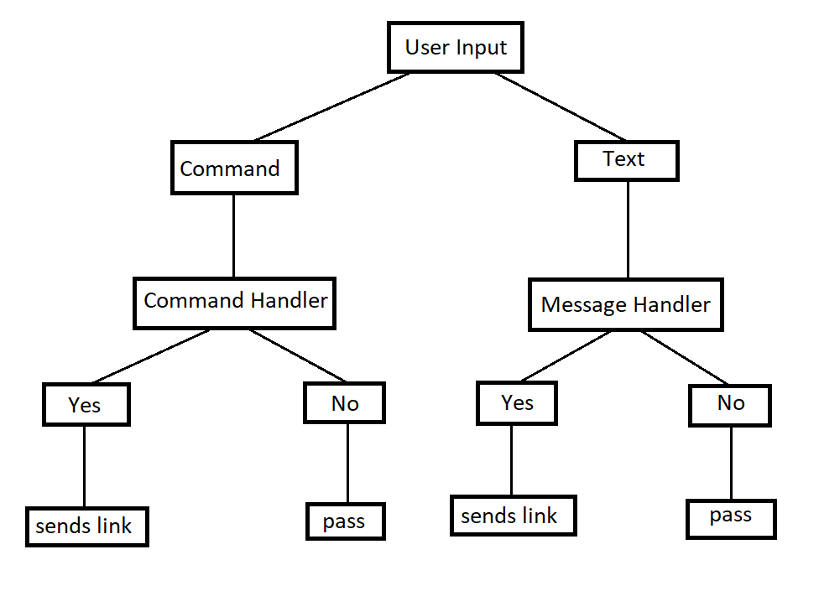

**Work Plan**

First of all we gathered in zoom session and discussed our ideas for project. Then we decided to make a bot. After that we distributed our roles: Alymbek a main programmer, Ellada a presentation part, and Iskender an editor.

Our meetings were held at 18:00 every weekends.

References

Programming Language – Python

Telegram Bot API - <https://core.telegram.org/bots/api#sendmessage>

Github Repository - <https://github.com/Isken-Human/Link-Bot>